DB-C4-S3-PRACTICE

(work as pair )

**Exercise 1** : [**w3chool tables**](https://www.w3schools.com/sql/trysql.asp?filename=trysql_select_where)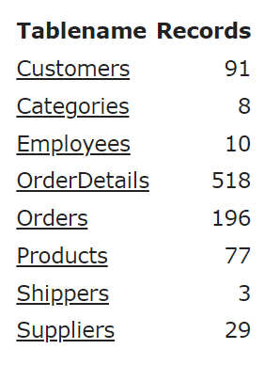

**Q1:** Design ERD of w3school database sample based on its own data.

**Q2:** Implement those table into phpMyAdmin

**Q3:** Insert at least 15 records per tables depend on each table.

(could be 10, 15, 20… ) by using SQL Query



**Exercise 2: ​**

A company needs to store information about movies and the director of movies

* Director are described by their name, date of birth, country
* Movies are described by their title; the date of release and their duration (in minutes)

Here is some more additional information:

* A movie can be directed by many directors.

**Q1:** What is the relation between Movie and Director? And why?

**Q2:** Do you need to create an intersection or association table? And why

**Q3:** Design ERD of Director & movie

**Q4:** Write the code to create those tables in MySQL

**Q5:** By searching on the internet, find at least 20 movies that are directed by approximately 5 different directors. Insert those needed information into the table above

**Q6:** Display all movies which have a duration of less than 1 hour and are released in 2021.

**Q7:** Display all movies and director names

**Q8:** Display all movies which has no director

**Q9:** Display all director who did not lead any movies

**Q10 :** Display all movies and director on our database.